Postal Life Insurance

Department of Post

Software Requirements Specification (SRS)/ Functional Requirements Specification (FRS)
  - Common Service Center (CSC)

INTERNAL APPROVAL FORM

Project Name: Common Service Center (CSC)
Version: 1.0
Submitted on:
 | Name | Date
Approved By:
Reviewed By:
Prepared By:

VERSION CONTROL LOG
Version | Date | Prepared By | Remarks
1

Table of Contents

1. Executive Summary 4
2. Project Scope 4
3. Business Requirements 4
4. Functional Requirements Specification 5
4.1 Customer Onboarding API 5
4.2 Payment Initiation API 6
4.3 Policy Status API 7
4.4 Grievance Registration API 7
4.5 Policy Services API 8
4.6 Service Request Indexing API 9
5. Attachments 9

1. Executive Summary
The purpose of this document is to define the requirements for integrating India Post’s PLI Insurance Management System (IMS) with the Common Service Centre (CSC) platform. This integration aims to enable customers to access PLI services digitally through CSCs, improving outreach, reducing dependency on physical post offices, and enhancing service efficiency.

2. Project Scope
The integration will allow CSC operators to perform:
- Customer Onboarding: New policy purchase, KYC validation, e-mandate registration.
- Policy Servicing: Premium payments, policy status checks, maturity/claim requests.
- Grievance Management: Complaint registration and resolution via CSC portal integrated with PLI CRM.
- Payment Integration: Premium collection through CSC payment gateway.

3. Business Requirements

ID | Functionality | Requirements
FS_CSC_001 | Customer Onboarding | Enable CSC operators to onboard new customers for PLI policies, including KYC validation and e-mandate registration.
FS_CSC_002 | Policy Issue | Allow CSC portal to initiate new policy proposals and send data to IMS for approval and issuance.
FS_CSC_003 | Premium Collection | Integrate CSC payment gateway with IMS for real-time premium payment updates and receipts.
FS_CSC_004 | Policy Servicing | Provide CSC operators access to financial (premium payment, loan requests) and non-financial (address change, nominee update) service request indexing.
FS_CSC_005 | Policy Status Check | Enable customers to check policy details and status through CSC portal using IMS APIs.
FS_CSC_006 | Grievance Management | Allow CSC portal to register complaints and sync with PLI CRM for resolution tracking.
FS_CSC_007 | Monitoring Dashboard | Provide dashboards for CSC transactions, API health, and grievance resolution metrics.

4. Functional Requirements Specification
Visual Flow Diagram for Common Service Center (CSC) Integration: 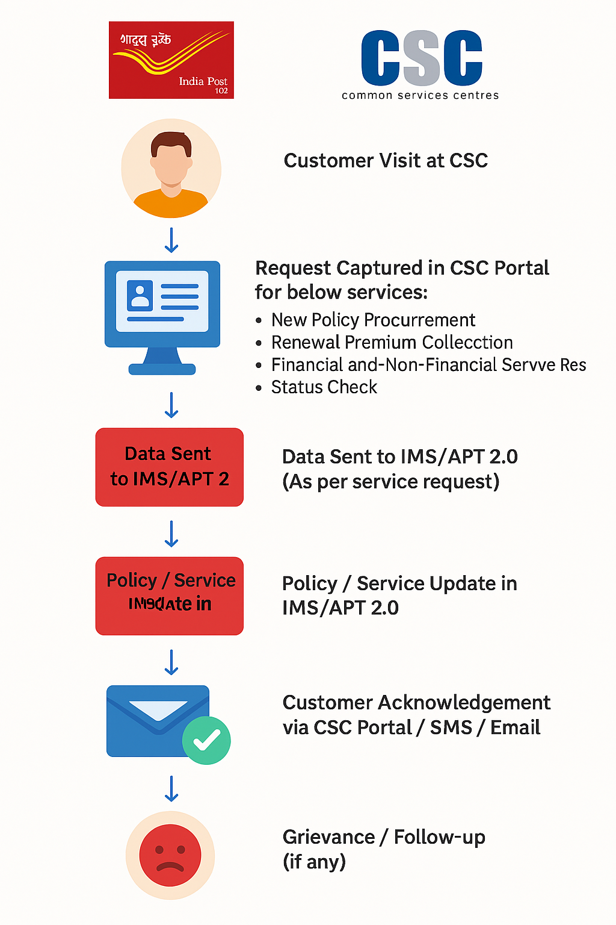

4.1 Customer Onboarding API
- Purpose: To onboard a new customer by capturing personal details, validating KYC, and initiating policy proposal.

4.1.1 Request Structure (CSC → IMS: Customer Onboarding API)

Field Name | Type | Description
customerName | String | Full name of the customer
aadhaarNumber | String | Aadhaar number for KYC validation
mobileNumber | String | Customer’s mobile number
email | String | Customer’s email address
address | String | Residential address
policyType | String | Type of policy (PLI / RPLI)
sumAssured | Decimal | Proposed sum assured
eMandateConsent | Boolean | Consent for e-mandate registration
ts | DateTime | Timestamp in ISO format

4.1.2 Response Structure (IMS → CSC: Customer Onboarding API)
Field Name | Type | Description
proposalNumber | String | Unique proposal number
status | String | Onboarding status (SUCCESS / FAILED)
message | String | Status message
ts | DateTime | Response timestamp

4.2 Payment Initiation API
- Purpose: To initiate the payment process by sending payment details to BBPS and receiving a payment link or status.

4.2.1 Request Structure (IMS → BBPS API: Payment Initiation API)
Field Name | Type | Description
policyNumber | String | Customer’s policy number
amount | Decimal | Payment amount
paymentType | String | FULL / ADVANCE
txn | String | Unique transaction ID
ts | DateTime | Timestamp in ISO format
bankPartner | String | Banking partner (e.g., SBI)
consent | Boolean | Customer consent flag

4.2.2 Response Structure (BBPS → IMS: Payment Initiation API)
Field Name | Type | Description
txn | String | Same transaction ID
status | String | Payment status (PENDING / SUCCESS / FAILED)
paymentUrl | String | URL for payment completion
message | String | Status message
ts | DateTime | Response timestamp

4.3 Policy Status API
- Purpose: To fetch the current status of a policy.

4.3.1 Request Structure (CSC → IMS: Policy Status API)
Field Name | Type | Description
policyNumber | String | Customer’s policy number
ts | DateTime | Timestamp in ISO format

4.3.2 Response Structure (IMS → CSC: Policy Status API)
Field Name | Type | Description
policyNumber | String | Policy number
status | String | Current policy status (ACTIVE / LAPSED)
nextPremiumDate | Date | Next premium due date
sumAssured | Decimal | Sum assured
ts | DateTime | Response timestamp

4.4 Grievance Registration API
- Purpose: To register a grievance and sync with PLI CRM.

4.4.1 Request Structure (CSC → IMS: Grievance Registration API)
Field Name | Type | Description
customerId | String | Unique customer ID
complaintType | String | Type of grievance
description | String | Detailed complaint description
ts | DateTime | Timestamp in ISO format

4.4.2 Response Structure (IMS → CSC: Grievance Registration API)
Field Name | Type | Description
grievanceId | String | Unique grievance ID
status | String | Registration status (SUCCESS / FAILED)
expectedResolution | String | Expected resolution time
ts | DateTime | Response timestamp

4.5 Policy Services API
- Purpose: To handle financial and non-financial service requests related to an existing policy (e.g., address change, nominee update, loan request).

4.5.1 Request Structure (CSC → IMS: Policy Services API)
Field Name | Type | Description
policyNumber | String | Customer’s policy number
serviceType | String | Type of service (ADDRESS_CHANGE / NOMINEE_UPDATE / LOAN_REQUEST)
details | JSON | Service-specific details (e.g., new address, nominee info)
customerId | String | Unique customer ID
ts | DateTime | Timestamp in ISO format

4.5.2 Response Structure (IMS → CSC: Policy Services API)
Field Name | Type | Description
requestId | String | Unique service request ID
status | String | Request status (PENDING / SUCCESS / FAILED)
message | String | Status message
ts | DateTime | Response timestamp

4.6 Service Request Indexing API
- Purpose: To log and index all service requests initiated via CSC for tracking and audit purposes.

4.6.1 Request Structure (CSC → IMS: Service Request Indexing API)
Field Name | Type | Description
requestId | String | Unique service request ID
policyNumber | String | Policy number associated with the request
serviceType | String | Type of service (ONBOARDING / PAYMENT / POLICY_SERVICE / GRIEVANCE)
status | String | Current status of the request
operatorId | String | CSC operator ID
ts | DateTime | Timestamp in ISO format

4.6.2 Response Structure (IMS → CSC: Service Request Indexing API)
Field Name | Type | Description
requestId | String | Same request ID
status | String | Indexing status (SUCCESS / FAILED)
message | String | Status message
ts | DateTime | Response timestamp

5. Attachments
The following documents can be referred.

